US Grade 8 – Pre-test
15 Questions | 60 minutes | Calculator allowed
1. Which equation represents the graph of a line on the coordinate plane that has an x-intercept of (2,0) and a y-intercept of (0,8)?
- $y=4x-8$
- $y=-4x+8$
- $y=-0.25x+8$
- $y=0.25x-8$

2. A sphere has a diameter of 10.2 cm. What is the volume of the sphere rounded to the nearest tenth, in cubic centimeters?
- 4,445.2
- 108.9
- 435.6
- 555.7

3. The points A(-2,2) and B(3,-8) are plotted on the coordinate plane. What is the distance between the points?
- $5\sqrt{5}$
- $125$
- $\sqrt{225}$
- 5

4. Which expressions have a value of $\frac{1}{64}$? Select all the correct answers.
- $(2^{3})^{-2}$
- $2^{-8}+2^{2}$
- $2^{8}×2^{-2}$
- $(2^{5})^{-1}$

5. Line T and Line R are parallel lines, cut by two transversals.
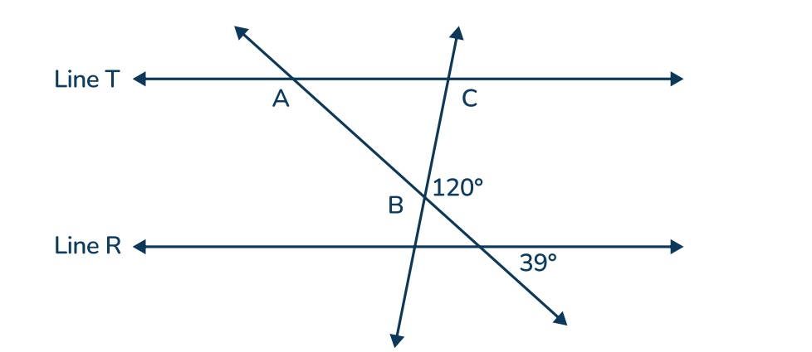
What interior angles make up the triangle ABC?
- 120, 39, 21
- 60, 39, 81
- 60, 39, 21
- 120, 39, 81

6. The distance from New York City to Jersey City is about $2.5×10^{5}$ inches.
The distance from New York City to Los Angeles is about $7.2×10^{4}$ times farther.
About how many inches is the distance from New York City to Los Angeles?
- $1.8×10^{10}$
- $18×10^{9}$
- $3.7×10^{1}$
- $0.37×10^{2}$

7. A container is in the shape of a cylinder that has a diameter of 8 inches and a height of 1.5 feet. Which equation can be used to find the volume of the container in cubic inches?
- $V=π(8)^{2}(1.5)$
- $V=π(4)^{2}(18)$
- $V=π(1.5)^{2}(8)$
- $V=π(8)^{2}(18)$

8. Which system of equations has infinite solutions?
- $y=-2x-4$
$y=2x+4$
- $x+y=2.5$
$x+2.5=y$
- $2y=x+4$
$-x+2y=8$
- $5x+5y=2$
$x=y+0.4$

9. Which sequence of transformations maps triangle ABC to triangle A’B’C’
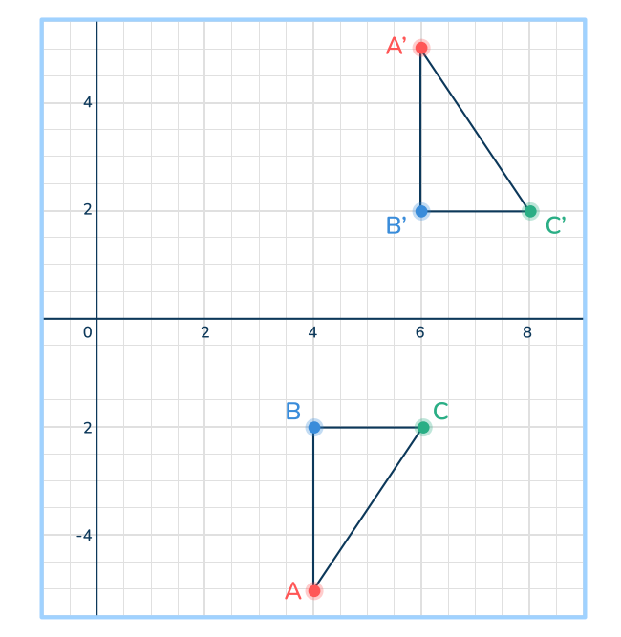
- Reflection over the line $y=x$ followed by a translation of 2 units up.
- Translation of 2 units right followed by a reflection over the y-axis.
- Reflection over the y-axis followed by a translation of 2 units up.
- Reflection over the x-axis followed by a translation of 2 units right.

10. Which numbers are irrational? Select all the correct answers.
- $\frac{1}{3}$
- $4π$
- $\sqrt{5^{2}}$
- $\sqrt{12}$

11. Which equation shows a line of best fit for the data?
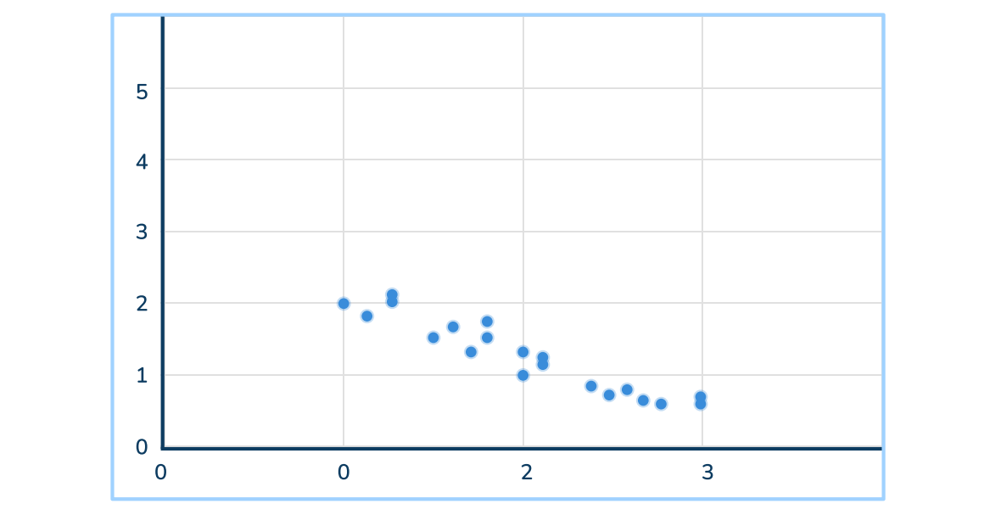
- $-0.8x+2.75=y$
- $0.7x+3=y$
- $2.8-x=y$
- $x-1=y$

12. Decide whether the triangle is acute, right, or obtuse.
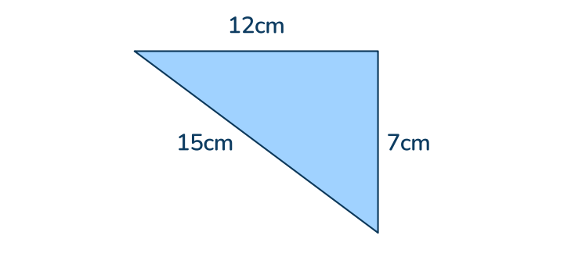
- acute
- right
- obtuse
- More information is needed

13. Simplify 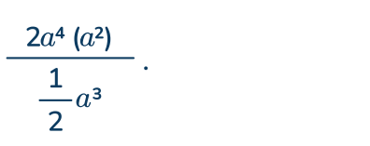
- $a^{3}$
- $4a^{2}$
- $a^{5}$
- $4a^{3}$

14. Write 7,080,000,000,000 in scientific notation.
- $7.08×10^{12}$
- $7.8×10^{13}$
- $708×10^{11}$
- $7.8×10^{14}$

15. What value for $k$ will make the equation have no solution?
$8x-26+2=k(\frac{1}{2}x-9)$

- $8$
- $16$
- $-\frac{1}{2}$
- $0$

